**Prediction performance on random permuted 16-digit matrix**

**Predictive models**

Four predictive models are applied in this experiment to investigate the effect of prediction performance on different permutations.

1. Linear SVM (SVM)
2. Group Learning (GL)
3. Neural network (NN)
4. Convolution neural network (CNN)

The detailed experimental settings are as follows:

- *positive class:* 16-digit matrix composed of digits ‘7’, ‘2’, ‘8’, ‘6’ (4 images for each digit, see Fig. 1);

- *negative class:* 16-digit matrix composed of digits ‘1’, ‘2’, ‘3’, ‘4’ (4 images for each digit, see Fig. 1);

- *feature vector (representing a 16-digit matrix)*

a. SVM: a real-valued vector of length 12544 (i.e., 16*28*28)

b. GL: 16 real-valued vectors of length 784 (i.e., 28*28)

c. NN & CNN: a real-valued matrix of size 112x112

- number of training inputs/matrices: 20, 40, 80, 160, 320 (equally distributed in two classes)

- number of validation matrices: 20, 40, 80, 160, 320 (equally distributed in two classes)

- number of test matrices: 1000 (500 per class)

**Datasets**

There are three types of 16-digit matrix datasets used in this experiment:

Dataset 1: Ordered matrix – see Fig. 1;

Dataset 2: Permuted-pixel matrix (**fixed** random pixel positions of whole matrix) – see Fig. 2;

Dataset 3: Permuted-image matrix (**varied** random image positions of whole matrix) – see Fig. 3.

Note that dataset 2 is generated by randomly permuting pixels of whole matrix in dataset 1, and the random pixel positions are fixed for all samples. Dataset 3 is generated by randomly permuting images of whole matrix in dataset 1, the positions of digit images are varied for each sample.

**Model selection**

The parameter C of SVM is selected via cross-validation, which generates the lowest validation error. GL is based on SVM, and the parameter C of SVM is selected via cross-validation as well. The real-valued outputs of SVM classifiers (corresponding to short group features) are combined to make a single prediction of GL. The threshold for making prediction of GL is estimated using validation data.

The parameters/structures of NN and CNN are used in the TensorFlow tutorials (<https://www.tensorflow.org/tutorials>) for classifying digit images in MNIST data. The NN has one hidden layer (regular densely-connected, 128 neurons, activation function = ‘ReLU’), and 20% neurons are randomly dropped-out. Two neurons in the output layer represent the predictions of two classes. The CNN is form (in sequence from first to last) by one convolution layer (with filters = 32, kernel size = 3x3, activation function = ‘ReLU’), one hidden layer (regular densely-connected, 128 neurons, activation function = ‘ReLU’), and one output layer (2 neurons).

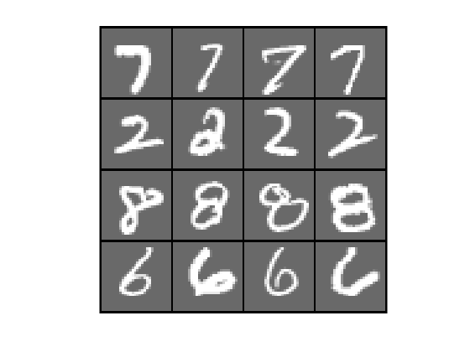 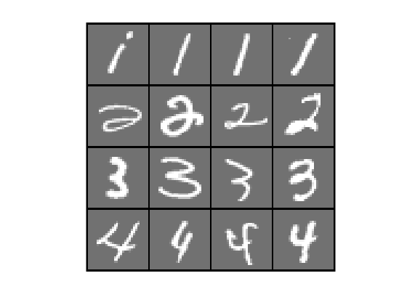

**Fig. 1.** Dataset 1, examples in positive (left) and negative (right) classes

**Fig. 2.** Dataset 2, examples in positive (left) and negative (right) classes

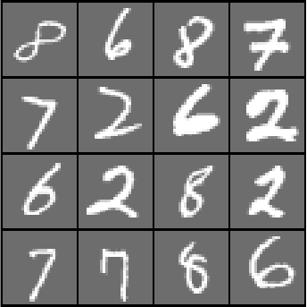 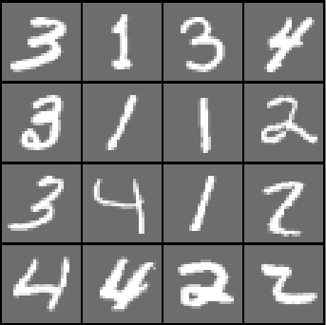

**Fig. 3.** Dataset 3, examples in positive (left) and negative (right) classes

**Result 1: Prediction performance of four models (SVM, GL, NN, CNN) on the three datasets**

The prediction (test) results of four models on datasets 1, 2, and 3 are shown in Tables 1, 2, and 3 correspondingly. Note that the training errors of all experiments (for all models applying to all datasets) are very small ~ 0.

For dataset 1, SVM and NN show the best prediction performance, both of them achieve SS=1.00, SP=1.00 for all training sample sizes (see Table 1). GL and CNN also show good prediction performance on dataset 1. However, when the training sample size is small, they make a small number of errors. This result may suggest that when the classification task is simple, and the training sample size is small, complex models (e.g., GL, CNN) may overfit the problem (because of the small training error ~ 0).

For dataset 2, the results are similar to the results of dataset 1 (see Tables 1 and 2). All models achieve good prediction performance. Especially for SVM, it still generates near-perfect classification. Randomizing the pixel positions (with fixed order for all samples) does not increase the level of challenge as it looks like.

For dataset 3, the difficulty of classification is increased, which can be observed from the degradation of prediction performance (see Table 3). Most models cannot show good prediction performance when the training sample size is small (< 40). Especially for NN and CNN, the degradation of prediction performance is very significant. However, GL still shows good prediction performance even for the small training sample size (< 40). From the histogram of projection of digit matrices (see Fig. 4), it is clear to see the distributions of two classes are overlapped. However, the adaptive threshold (estimated using validation data) can effectively separate the two classes in decision space.

Fig. 5 improves the understanding of the relationship between training sample size and performance indices (SS and SP). The prediction performances of all models are improved by increasing the training sample size. Significant improvements can be found on NN and CNN. Their SS and SP are poor and unstable initially when the training sample size is less than or equal to 40. After increasing the training size to 160, they can achieve performance comparable to SVM and GL (but still inferior to them).

In summary, when the classification problem is simple, SVM shows the best and stable prediction performance. Complex models (e.g., GL and CNN) may overfit the simple problem. On the contrary, when the difficulty of classification increases, GL shows the best prediction performance. Remarkably, when the training sample size is small (< 40), GL still shows excellent prediction performance.

**Table 1.** Prediction performance of four models on dataset 1 (models are trained using five different samples sizes)

|  |  |  |  |  |  |  |  |  |
| --- | --- | --- | --- | --- | --- | --- | --- | --- |
| # training samples | SVM | | GL | | NN | | CNN | |
| SS | SP | SS | SP | SS | SP | SS | SP |
| 20 | 1.00±0.00 | 1.00±0.00 | 1.00±0.00 | 0.94±0.04 | 1.00±0.00 | 1.00±0.00 | 0.97±0.06 | 1.00±0.00 |
| 40 | 1.00±0.00 | 1.00±0.00 | 1.00±0.00 | 0.94±0.04 | 1.00±0.00 | 1.00±0.00 | 1.00±0.00 | 0.99±0.01 |
| 80 | 1.00±0.00 | 1.00±0.00 | 1.00±0.00 | 0.98±0.02 | 1.00±0.00 | 1.00±0.00 | 1.00±0.00 | 1.00±0.00 |
| 160 | 1.00±0.00 | 1.00±0.00 | 1.00±0.00 | 0.99±0.01 | 1.00±0.00 | 1.00±0.00 | 1.00±0.00 | 1.00±0.00 |
| 320 | 1.00±0.00 | 1.00±0.00 | 1.00±0.00 | 1.00±0.00 | 1.00±0.00 | 1.00±0.00 | 1.00±0.00 | 1.00±0.00 |

**Table 2.** Prediction performance of four models on dataset 2 (models are trained using five different samples sizes)

|  |  |  |  |  |  |  |  |  |
| --- | --- | --- | --- | --- | --- | --- | --- | --- |
| # training samples | SVM | | GL | | NN | | CNN | |
| SS | SP | SS | SP | SS | SP | SS | SP |
| 20 | 1.00±0.00 | 1.00±0.00 | 1.00±0.00 | 0.93±0.03 | 0.98±0.04 | 0.99±0.02 | 0.99±0.01 | 0.98±0.03 |
| 40 | 1.00±0.00 | 1.00±0.00 | 1.00±0.00 | 0.95±0.02 | 1.00±0.00 | 0.99±0.01 | 1.00±0.00 | 0.99±0.01 |
| 80 | 1.00±0.00 | 1.00±0.00 | 1.00±0.00 | 0.99±0.01 | 1.00±0.00 | 1.00±0.00 | 1.00±0.00 | 1.00±0.00 |
| 160 | 1.00±0.00 | 1.00±0.00 | 1.00±0.00 | 0.99±0.01 | 1.00±0.00 | 1.00±0.00 | 1.00±0.00 | 1.00±0.00 |
| 320 | 1.00±0.00 | 1.00±0.00 | 1.00±0.00 | 1.00±0.01 | 1.00±0.00 | 1.00±0.00 | 1.00±0.00 | 1.00±0.00 |

**Table 3.** Prediction performance of four models on dataset 3 (models are trained using five different samples sizes)

|  |  |  |  |  |  |  |  |  |
| --- | --- | --- | --- | --- | --- | --- | --- | --- |
| # training samples | SVM | | GL | | NN | | CNN | |
| SS | SP | SS | SP | SS | SP | SS | SP |
| 20 | 0.91±0.02 | 0.82±0.05 | 1.00±0.00 | 0.96±0.03 | 0.87±0.14 | 0.62±0.25 | 0.72±0.29 | 0.61±0.37 |
| 40 | 0.96±0.02 | 0.89±0.04 | 1.00±0.00 | 0.96±0.03 | 0.77±0.25 | 0.80±0.18 | 0.99±0.01 | 0.55±0.18 |
| 80 | 0.97±0.01 | 0.97±0.01 | 1.00±0.00 | 0.98±0.03 | 0.96±0.02 | 0.94±0.02 | 0.97±0.03 | 0.95±0.02 |
| 160 | 0.99±0.01 | 0.99±0.00 | 1.00±0.00 | 0.98±0.01 | 0.97±0.02 | 0.98±0.02 | 0.98±0.01 | 0.97±0.01 |
| 320 | 1.00±0.00 | 0.99±0.01 | 1.00±0.00 | 1.00±0.00 | 1.00±0.00 | 0.97±0.02 | 0.99±0.00 | 0.99±0.00 |

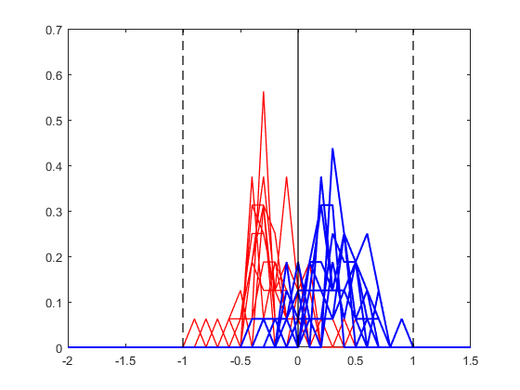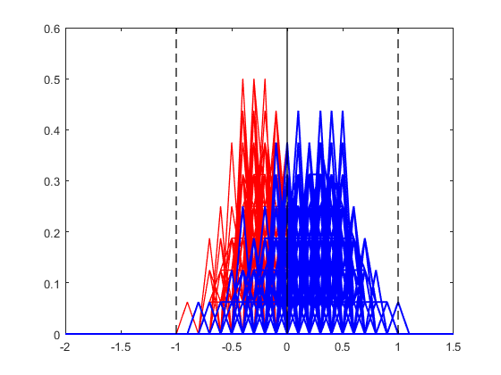

**Fig. 4.** Histograms for digit matrices in dataset 3 and the corresponding bivariate decision space for discriminating between positive and negative. Adaptive thresholds are indicated as dashed lines. Histograms for 20 training samples (upper left); Histograms for 1000 test samples (upper right); Decision space for training samples (bottom left); Decision space for test samples (bottom right).

**Fig. 5.** The test SS(left) and SP(right) as a function of training sample size of dataset 3 for four models (SVM, GL, NN, and CNN).

**Result 2: Prediction performance of four models on dataset 3 with different degree of overlap (50% and 75%)**

In the previous section, we have investigated the prediction performance on dataset 3 (i.e., digit matrices with 25% overlap). In this section, we further investigate the prediction performance of four models on digit matrices with 50% and 75% overlaps. The datasets with 50% and 75% overlaps are generated by changing the digits composing Dataset 3 as follows:

- 50% overlap: positive class: digits ‘1, 2, 6, 8’, negative class: digits ‘1, 2, 3, 4’ – see Fig. 6.

- 75% overlap: positive class: digits ‘1, 2, 3, 6’, negative class: digits ‘1, 2, 3, 4’ – see Fig. 7.

The prediction performance of four models on the two datasets with 50% and 75% overlaps are shown in Tables 4 and 5 correspondingly. Note that the training error is close to zero; hence, only the test result is presented. Clearly, the prediction performance is decreased by increasing the overlap for all models.

Figs. 8 and 9 show the relationship between training sample size and performance indices (SS and SP) in Tables 4 and 5. Through Figs. 8 and 9, it is easier to compare prediction performance under different training sample size for four models. Overall, GL shows the best prediction performance, especially when the training size is small (< 40). 50% overlap almost does not affect the prediction performance of GL. However, 75% overlap affects the prediction performance of GL. The overlap of two classes can be observed in Figs 10 and 11. When the overlap = 50% (see Fig. 10), the histograms of positive classes are on the right

SVM shows good prediction performance on 50% overlapped dataset. However, when the overlap level increases to 75%, SVM shows the worst prediction performance among the four methods. NN and CNN generally generate poor and unstable prediction when the training sample size is small (< 80), and their prediction performances are improved significantly by increasing the training sample size. Especially for CNN, when the training sample size is large enough (say 320), it can achieve excellent prediction performance.

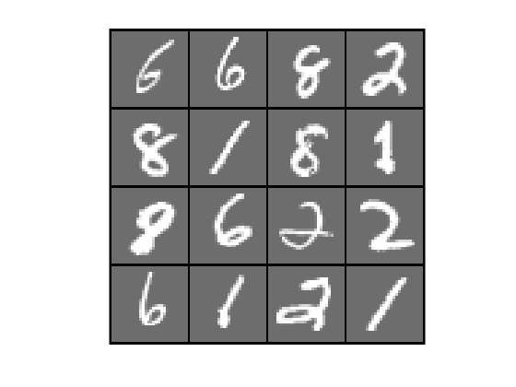 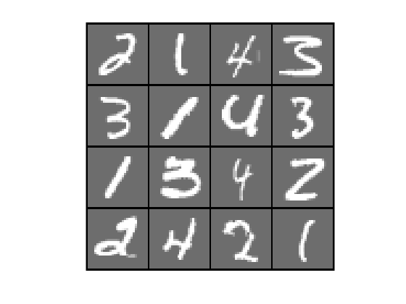

**Fig. 6.** Dataset 3 (with 50% overlap), examples in positive (left) and negative (right) classes

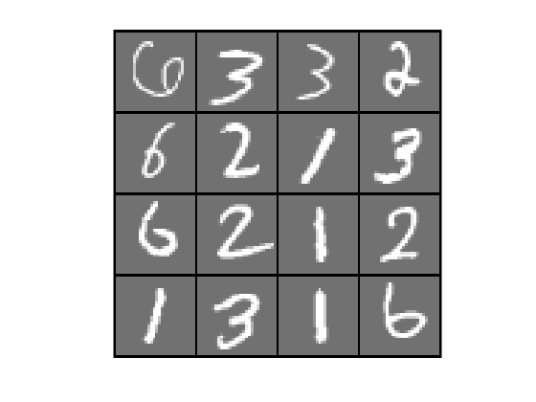 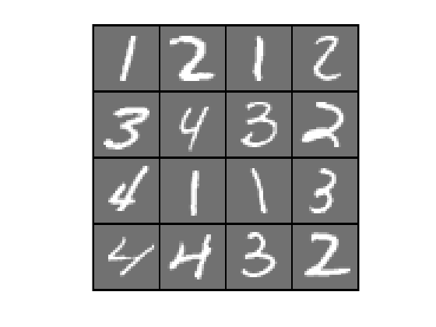

**Fig. 7.** Dataset 3 (with 75% overlap), examples in positive (left) and negative (right) classes

**Table 4.** Prediction performance of four models on dataset 3 with 50% overlap (models are trained using five different samples sizes)

|  |  |  |  |  |  |  |  |  |
| --- | --- | --- | --- | --- | --- | --- | --- | --- |
| # training samples | SVM | | GL | | NN | | CNN | |
| SS | SP | SS | SP | SS | SP | SS | SP |
| 20 | 0.89±0.04 | 0.59±0.06 | 1.00±0.00 | 0.90±0.07 | 0.91±0.16 | 0.26±0.33 | 0.80±0.31 | 0.44±0.37 |
| 40 | 0.89±0.04 | 0.81±0.05 | 1.00±0.00 | 0.97±0.04 | 0.83±0.21 | 0.62±0.25 | 0.90±0.07 | 0.70±0.12 |
| 80 | 0.93±0.04 | 0.89±0.04 | 1.00±0.00 | 0.97±0.01 | 0.93±0.09 | 0.66±0.32 | 0.93±0.04 | 0.90±0.04 |
| 160 | 0.96±0.04 | 0.97±0.00 | 1.00±0.00 | 0.98±0.02 | 0.89±0.13 | 0.86±0.15 | 0.96±0.03 | 0.94±0.04 |
| 320 | 0.97±0.03 | 0.99±0.00 | 1.00±0.00 | 0.99±0.01 | 0.99±0.00 | 0.93±0.05 | 0.99±0.00 | 0.99±0.01 |

**Table 5.** Prediction performance of four models on dataset 3 with 75% overlap (models are trained using five different samples sizes)

|  |  |  |  |  |  |  |  |  |
| --- | --- | --- | --- | --- | --- | --- | --- | --- |
| # training samples | SVM | | GL | | NN | | CNN | |
| SS | SP | SS | SP | SS | SP | SS | SP |
| 20 | 0.65±0.08 | 0.64±0.07 | 0.81±0.18 | 0.83±0.18 | 0.70±0.40 | 0.39±0.42 | 0.52±0.35 | 0.65±0.38 |
| 40 | 0.63±0.02 | 0.73±0.04 | 0.83±0.10 | 0.93±0.04 | 0.56±0.33 | 0.69±0.34 | 0.72±0.22 | 0.72±0.19 |
| 80 | 0.66±0.06 | 0.82±0.06 | 0.83±0.15 | 0.90±0.09 | 0.78±0.19 | 0.71±0.26 | 0.85±0.03 | 0.83±0.05 |
| 160 | 0.67±0.06 | 0.90±0.04 | 0.90±0.01 | 0.94±0.02 | 0.89±0.07 | 0.83±0.13 | 0.92±0.03 | 0.91±0.01 |
| 320 | 0.67±0.03 | 0.95±0.02 | 0.86±0.07 | 0.96±0.02 | 0.90±0.08 | 0.96±0.03 | 0.97±0.01 | 0.96±0.01 |

**Fig. 8.** The test SS(left) and SP(right) as a function of training sample size of dataset 3 (50% overlap) for four models (SVM, GL, NN, and CNN).

**Fig. 9.** The test SS(left) and SP(right) as a function of training sample size of dataset 3 (75% overlap) for four models (SVM, GL, NN, and CNN).

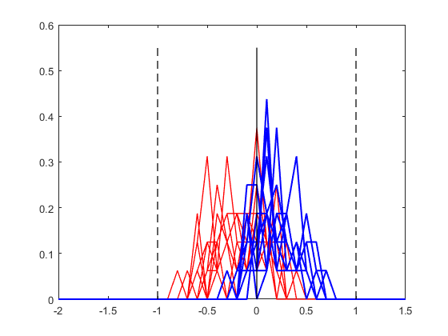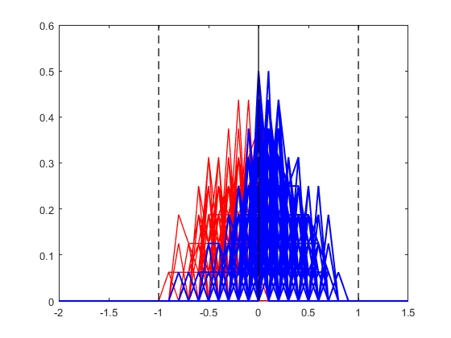

**Fig. 10.** Histograms for digit matrices in dataset 3 (50% overlap) and the corresponding bivariate decision space for discriminating between positive and negative. Adaptive thresholds are indicated as dashed lines. Histograms for 20 training samples (upper left); Histograms for 1000 test samples (upper right); Bivariate decision space for training samples (bottom left); Bivariate decision space for test samples (bottom right)

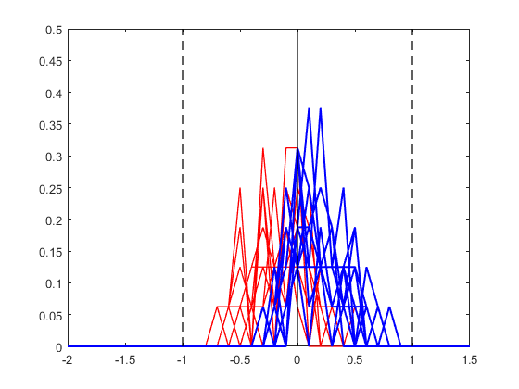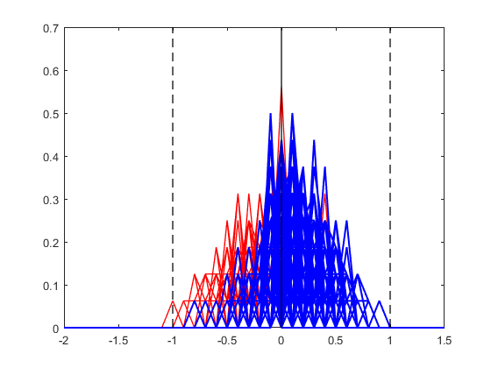

**Fig. 11.** Histograms for digit matrices in dataset 3 (75% overlap) and the corresponding bivariate decision space for discriminating between positive and negative. Adaptive thresholds are indicated as dashed lines. Histograms for 20 training samples (upper left); Histograms for 1000 test samples (upper right); Bivariate decision space for training samples (bottom left); Bivariate decision space for test samples (bottom right)